LTspice Simulations of a Transmission Line

Lab 2 (Winter 2015)

I. Objective: Gain familiarity with transmission line parameters by applying LTspice simulations.

II. Background: The text shows that a transmission line can be modeled with a number of distributed lumped circuit elements. Those elements determine the attenuation, phase constant, and impedance of the transmission line. During the course of this laboratory simulation exercise you will investigate the importance of the distributed lumped element model of a transmission line.

III. Initial calculations: The common RG-58 coaxial cables have the following parameters: Distributed capacitance=95 pF/m, and distributed inductance=240 nH/m. (Assume the coax is lossless.) Determine the following at 500 kHz, 1 MHz, 2MHz, 5 MHz, 10 MHz, and 20 MHz:

Characteristic impedance, phase constant, phase velocity and overall capacitance of a 10-meter RG-58 cable.

IV. Procedure: (This is an individual exercise to be performed without a lab partner.) In this section I have given specific values for elements and parameters to get consistency in results, **but you will have extra benefit if you experiment with different values to gain additional insight into what you are modeling.**

1. Make a model of a 10-meter RG 58 coaxial line using 10 segments as shown in the accompanying figure. What is the simulated distance spanned by each segment? Comment on the physical meaning of the values chosen for each of the elements in this circuit, including the load and source resistors.

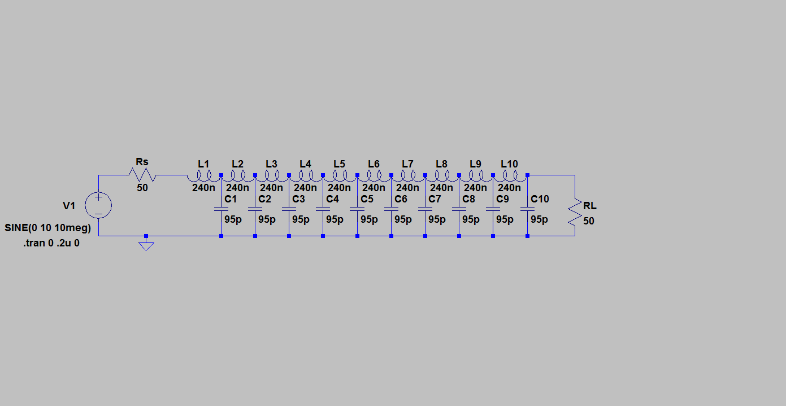

1. Look at the response of this circuit at frequencies 500 kHz, 5 MHz, 10 MHz and 20 MHz. Experiment with the time window for each frequency so that you can make sense of what you are seeing. Comment on changes that occur as you change frequencies.
2. Compare the voltage waveforms at the load and source for each of the different nodes between the inductors. Determine the phase velocity based on the delay between segments and the length you calculated for each segment from (1.). Compare this for all of the specified frequencies of the source voltage to the initial calculation values. Explain why this is so hard to do at 500 kHz.

V. Conclusion: Describe in general what you have learned from this exercise. Be sure to discuss the relationship between lumped element parameters and transmission lines.

VI. Exploration and Creativity: One of the important characteristics of a good engineer is their ability to ask well-informed what-if questions. Considering the results of this lab, come up with circuit/parameter modifications that will help you verify your intuition about transmissions lines and/or help you explore what we have done in more depth**. (This portion of the laboratory exercise is worth 10% of your lab grade. You will be graded leniently on the creativity and relevance of your modifications. You must explain the rationale for your modifications and the significance of the result to get the points.)**